**A LOCATION SEARCH FOR A NEW BOOKSHOOP TO BE LOCATED WITHIN THE NEIGBORHOOD OF EXISTING UNIVERISTIES IN MANHANTTAN BOROUGH, NEW YORK, UNITED STATES OF AMERICA (USA). A PROPOSAL TO THE ASSOCIATED PRESS UNION USA**

**BY**

**TOCHUKWU CALEB OKEKE**

**DATE: 21/6/2021**

**1.0 Introduction/Background**

The Associated Press Union (APU) of the United States of America (USA) proposes a bookshop that would be located in one of the counties in the city of New York. Preliminary survey shows that the reading culture in New York City is high and there is high demand for quality reading materials. New York is one of the 50 states in the United State of America (USA) with a strong economic base. A search from Wikipedia shows that there are 594,000 university students in New York city attending 110 universities and colleges, and this is the largest school district in the USA. A post by Laura (2021) shows top eight universities in New York, from which three universities namely New York university, City university and Columbia university of New York. Luckly, the main campus of these three universities is located in the Manhanttan and therefore the scope of this search is limited to Manhanttan Borough, New York state.

APU members expects the proposed bookshop to be located in the neighborhood of these three existing universities. Foursquare provide rich source of location information and will be used for location data sourcing. Data on population was also obtained from Kaggle for this purpose. Condition considered in the selection of best spot includes:

1. The proximity to existing bookshops within the neighborhood of these universities. These bookshops offer similar service, and is important to map their locations within the neighborhood, to avoid selecting location with large cluster of old bookshops and low student population.
2. Proximity of the neighborhood of Manhanttan to the different campuses of the three universities.
3. Population and income analysis of Manhattan using information obtained from Kaggle.
4. Location map plotting using Folium
   1. **Problem**

This major challenge to physical bookshop is the alternative online sourcing. To overcome this challenge, other facilities like library service, recreational and exercise activities will be incorporated in the bookshop to make the place attractive. Therefore, the need to understudy the kind of services offered by other existing bookshops and see how to improve on this for better service delivery. The first activity is to location of existing universities and examine the bookshops located within their neighborhood. Also map the existing campuses of this universities and their existing neighborhood of boroughs in which these campuses are located. New City university is one of the most populated universities with 25 different campuses located in the 5 boroughs of New York, but our search will be limited to the borough of Manhattan. To find a best location of the proposed bookshop, a location information of the universities campuses and neighborhood were obtained and mapped. A Jason file that contains information on the Manhanttan borough was also use to sort information on Manhanttan, and the neighborhoods were clustered.

1. **Data**

**2.1 Location information and student population**

Location information was obtained from foursquare, student population form online source, and information on population and income of Manhanttan Borough from the Kaggle. Foursquare has a large data information about location and places of interest, and this information were assessed using foursquare API. Student population information were obtained from the different school websites. Kaggle is a subsidiary of google LLC, and online community of data scientist and store of data on different things.

**New York University:** The New York University student population is 51, 123, and the campuses of New York university are located in two boroughs namely Manhattan and Brookyln.

**City University of New York :** City University New York, USA, is the largest urban university system in the United States of America, comprising of 25 campuses located in the 5 boroughs of New York state. The university enrolls over 275, 000 students and offers different varieties of courses.

**Columbia University:** This is the oldest institution in New York state and is one of the colonial colleges founded pre-independence, and has a student population is 33,143.

**2.2. Existing bookshop information**

A search query to get location and rating information about existing bookshop that may act as competitors. This required using the location coordinate of the different universities in the venue search on foursquare API. This gave location information of existing bookshops at a specified radius to the universities. This information was obtained in a Jason file

**2.3 Neighborhood information**

To explore areas around the different universities to know the business actives that thrive. The three universities are located in Manhanttan Borough USA and therefore neighborhood information was sort for this purpose. Manhanttan borough neighborhood information was obtained from foursquare and explored to business that thrive around this universities. Based on these neighborhood, clusters were created.

**2.4 Student Population information**

This was obtained through a search on the three universities websites. The three universities are located in the same neighborhood and have different department, colleges and campus. City university has 25 campuses, 11 of which are located in the Manhanttan borough. A total of 28 campuses was noted with city university having the majority population amongst the three.

**2.5 Population and income of Manhanttan Borough New York, USA**

Information for this purpose was obtained from Kaggle in an excel file. Basic descriptive statistic was done and related information were obtained.

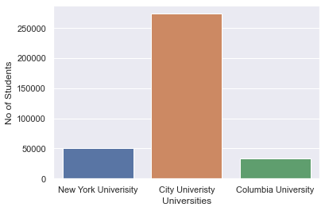

Figure 1: The population of university Students

**3.0 Methodology**

**Locating the coordinates of the three Universities**

Using google geolocator, the latitude and longitude of the three universities were obtained, and mapped using python folium Map. A sample of the gelocator code script is shown below:

address = 'New York University, New York, USA'

geolocator = Nominatim(user_agent="foursquare_agent")

location = geolocator.geocode(address)

latitude = location.latitude

longitude = location.longitude

print(latitude, longitude)

**3.1 Using the foursquare API, location information**

The information sort using the foursquare API include:

1. A search query to get location and rating information about existing bookshop that may act as competitors.
2. To explore areas around the different universities to know the business actives that thrive.
3. To create clusters around selected locations based on information obtained from Foursquare API.

**3.2 Location mapping using Folium**

City university New York has 25 campuses scatter about the 5 boroughs of New York City. The New York University has 2 campus and Columbia University has one campus, bring the total number of campus is 28. The location address of the different campus was obtained from online source and their coordinates gotten through google geolocator, and were mapped using python Folium.

**3.3 The neighborhood of Manhattan**

The three universities all have their main campus in Manhattan borough New York, and it is expedient to map the neighborhood of Manhattan in relation to the university’s locations. A Jason file that contains location information of entire New York State was used for this purpose, from which the venue information about the neighborhood of Manhattan was extracted.

**3.4 Exploring neighborhood of the Universities**

The New York university is located in Greenwich town and locations around this area was explore and cluster of similar features was created. This required using one-hot encoding to create dummy and to K-cluster to create clusters.

**3.5 Population and income information of New York**

An excel file containing population and income information for New York was obtained from Kaggle and used for this purpose.

**4.0 Result and Discussion**

**4.1 Neighborhood information**

New York University has a student population of nearly 51000 and is located in the neighborhood of Manhanttan away from city university and Columbia university. The main campus of City and Columbia universities are located at close proximity to each other. The City University has 25 campuses located in the 5 boroughs of New York – with green location marker (Figure 2).

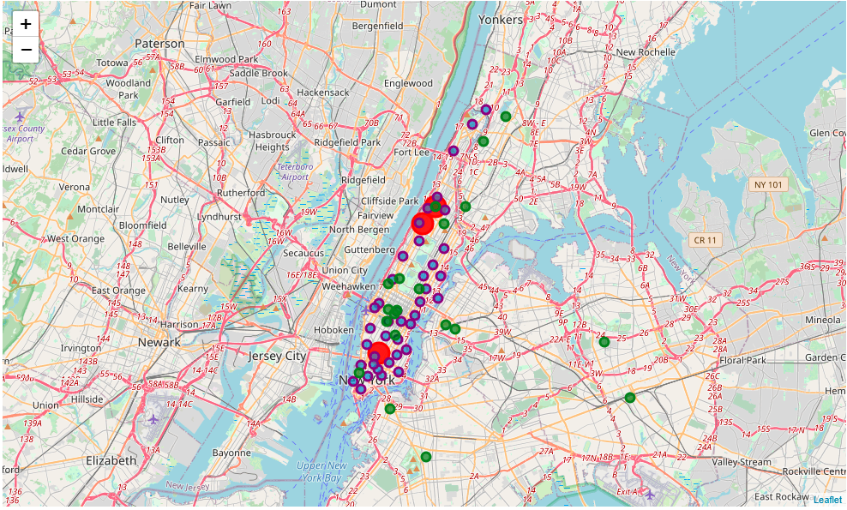

Figure 2: The location of the universities campuses in the neighborhood of Manhattan

The purple location markers are for the neighborhood of Manhanttan borough – selected to reduce the scope of study. Majority of these campuses of city university are located in Manhanttan borough, and figure 3 shows higher intensity of neighborhood cluster around the New York University. Next therefore is explore the proximity of existing bookshops around these universities.

**4.2 The proximity of existing bookshops around the university’s campuses**

Most of the existing bookshops are located downtown and are clustered around the New York University. No bookshop is located at 1000-meter distance to the main campus of both City university and Columbia university, The closest bookshop to city university main campus is at 2000 meters, and the closest bookshop to the Columbia university occurred after the 3000-radius mark (Table 1). At a 1000 meter radius, there exist a total of 6 bookshops around the new York university main campus. The line plot in Figure 3, indicates two sharp steep rising slope in the line graph of NYU i.e at a radius of 5000 meters, a count of 18 different bookshops were observed, and after which a mild gradual slope was observed. This may be attributed to the high cluster of campuses of City University and the neighborhood of Manhanttan (Figure 2). The line plots of CUNY and CU show similar patterns with steady rise after the 5000 meter radius.

Table 1: No of Bookshops in relation to distance from

|  |  |  |
| --- | --- | --- |
| S/n | Radius | No of Bookshops |
|  | New York University |  |
| 1 | 20000 | 23 |
| 2 | 7000 | 18 |
| 3 | 5000 | 17 |
| 4 | 3000 | 10 |
| 5 | 1000 | 6 |
|  | City University of New York |  |
| 1 | 20000 | 26 |
| 2 | 7000 | 4 |
| 3 | 5000 | 1 |
| 4 | 3000 | 1 |
| 5 | 1000 | 0 |
|  | Columbia University |  |
| 1 | 20000 | 26 |
| 2 | 7000 | 8 |
| 3 | 5000 | 3 |
| 4 | 3000 | 0 |
| 5 | 1000 | 0 |

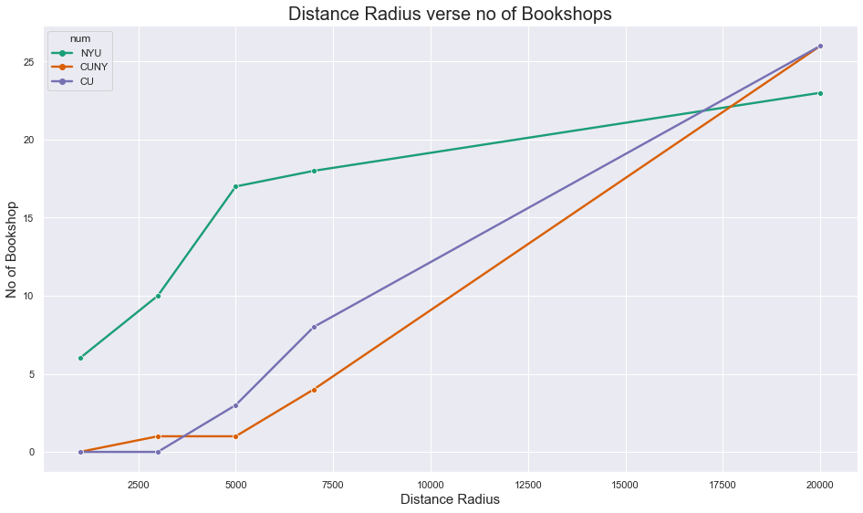

Figure 3: The line plot of distance radius and number of available bookshops

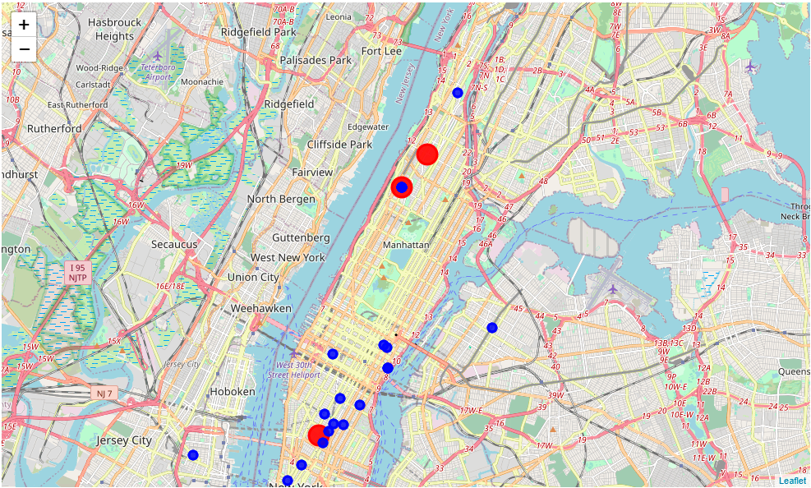

Figure 4: The location of the bookshops within the neighborhood of the existing univeristies.

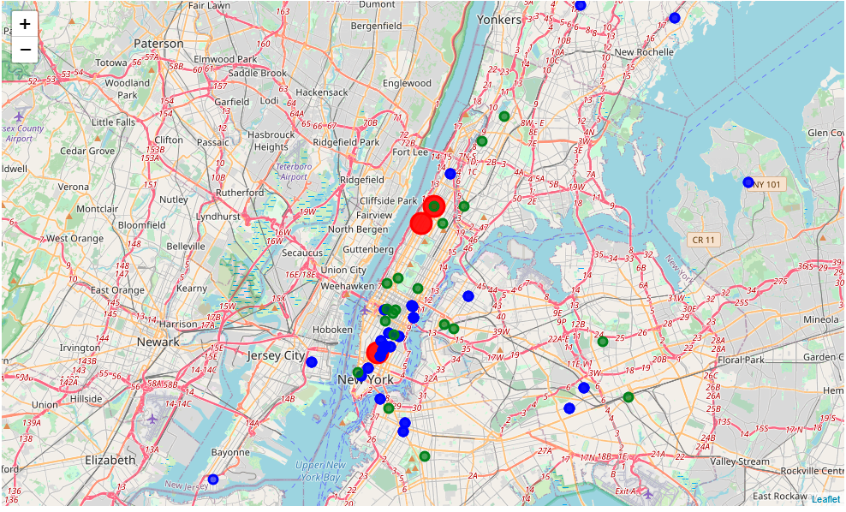

Figure 5: The location of the campuses and the existing bookshops

Figure 5 shows that there are few bookshops around the City and Columbia university. Reason why may be still unknown, but the reason for the clustering of existing bookshops around the New York university may be related to the number of campuses around that location. The high student population will certainly attract more bookshops. A cluster of city university campuses are located within this neighborhood, and also much neighborhood of Manhanttan is are within this district (Figure 2). If the proposed bookshop must be located with the borough of Manhattan, the two choice now exist.

**4.3 The population and income statistics of Manhanttan**

The sub plot below shows the proportion of employed and unemployed people, proportion of male and female in Manhattan. 54.3% of the entire population are employed while 45.7% are unemployed. The borough has more females than male. The poverty rate is 18.7%, the unemployment rate is 8.00%, and the income per capital is 69351. The income per captia for Mahanttan is impressive, as well as the unemployment rate, but the poverty rate seems a bit disturbing. This may be due to large presence of immigrants in the vicinity. Also, the median age for the state of New York is less than 40 years. This shows that large population of the citizens are youthful men and women. This statistic is favorable for incoming investor. Also new York is the state with the highest student population in the united states and and attractive place for investors.

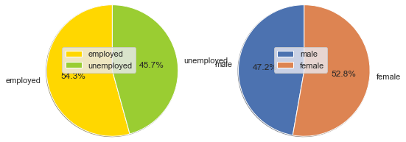

Figure 6: The bar chart

Figure 1 shows that the student population of City university far exceeds that of the other three universities. City university has 25 campuses, 11 of which are located in the Manhanttan borough. The City university campuses located in Manhattan are clustered around the new York university and more majority of the existing bookshops are located in that area. It is therefore expedient to create clusters using K-mean of neighborhood around this location.

**4.4 Neighborhood around the Greenwich town – the location of New York university**

Folium map visualization shows that the neighborhood of Manhattan is clustered around New York, more bookshops and campuses are located in these areas. The neighborhood around city and Columbia universities has only few bookshops around and more located at far distance. Locating the university in this location may not enjoy large volume patronage, but has the advantage of a limited presence of competitor bookshops. Therefore, the need to evaluate the cluster around the Greenwich neighborhood of Manhattan.

The initial count of unique categories of shops, restaurants, clubs and other leisure attractions shows 100 different unique classes. The venues are accessories store, restaurants, shops, bakery, bar, boutique, brewery, café, joints, clubs, gyms, health and beauty service, studios and places.

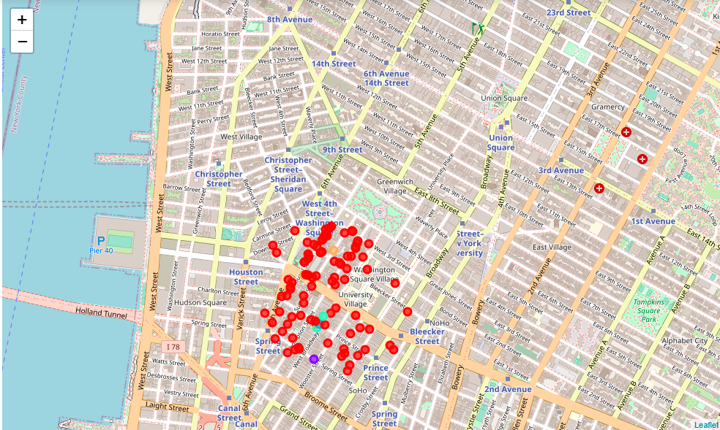

Figure 7: The cluster groupings around Greenwich town

**4.6 The location and coordinates of the campuses**

The location address and coordinates of the 25 colleges of city university New York, USA are

1. Baruch College: Located in 55 Lexington Avenue, Manhattan, New York, USA. The coordinates are 40.74019335, -73.98332973364073
2. Borough of Manhattan Community College: Located in MANHATTAN**– 199 Chambers Street, New York, USA. The coordinates are** 40.7172487, -74.0121804
3. Bronx community college: Located in BRONX**– 2155 University Avenue, New York, USA. The coordinates are** 40.857684649999996, -73.91289615614554
4. Brookyln College: Located in the BROOKLYN**– 2900 Bedford Ave, New York, USA. The coordinates are** 40.63175995, -73.95348121612278
5. College of Staten Island: Located in the STATEN ISLAND**– 2800 Victory Boulevard, New York, USA. The coordinates are** 40.60758, -74.159282.
6. Craig Newmark Graduate School of Journalism: Located in the MANHATTAN**– 219 W 40th Street, New York, USA. The coordinates are** 40.7553245, -73.9889879
7. CUNY graduate Center: located in MANHATTAN**– 365 Fifth Avenue, New York, USA. The coordinates are** 42.70965401010101, -73.71083494949495.
8. CUNY Graduate School of public Health and Health Policy: Located in the MANHATTAN**– 55 W 125th Street, New York, USA. The coordinate are** 40.8073215, -73.9439667
9. CUNY School of labor and Urban Studies: Located in MANHATTAN**– 25 West 43rd Street, New York, USA. The coordinate is** 40.754875, -73.9817101
10. CUNY School of Law: Located in QUEENS**– 2 Court Square, New York, USA. The coordinates are** 40.746246, -73.942895
11. CUNY School of Professional Studies: Located in MANHATTAN**– 119 W 31st Street, New York, USA. The coordinates are** 40.7483872 -73.990094
12. Guttman Community College: Located in MANHATTAN**– 50 W 40th St, New York, USA. The coordinates are** 40.752949, -73.9840106
13. Hostos Community College: Located in BRONX**– 500 Grand Concourse, New York, USA. The coordinate are** 40.8180719, -73.9268413875
14. Hunter College: Location in MANHATTAN**– 695 Park Ave, New York, USA. The coordinates are** 40.7683107, -73.9644059567109
15. John Jay College of Criminal Justice: Located in MANHATTAN**– 524 W 59th St, New York, USA. The coordinates are** 40.7710723, -73.9888429
16. Kingsborough Community College: Located in BROOKLYN**– 2001 Oriental Blvd, New York, USA. The coordinates are** 40.578191849999996, -73.93496554856793
17. LaGuardia Community College: Located in QUEENS**– 31-10 Thomson Ave, New York, USA. The coordinates are** 40.7438487 -73.935166587143
18. Lehman College: Located in BRONX**– 250 Bedford Park Blvd West, New York, USA. The coordinates are** 40.8722825 -73.8948917141949
19. Macaulay Honors College: Located in MANHATTAN**– 35 W 67th St, New York, USA. The coordinates are** 40.7740627 -73.98005097388125
20. Medgar Ever College: Located in BROOKLYN**– 1650 Bedford Ave, New York, USA. The coordinates are** 40.6662941 -73.95836331384717
21. New York City College of Technology: Located in BROOKLYN**– 300 Jay St, New York, USA. The coordinates are** 40.6952788 -73.9873073
22. Queen College: Located in QUEENS**– 65-30 Kissena Boulevard, New York, USA. The coordinates are** 40.7359546 -73.81588506522962
23. Queensborough Community College: Located in QUEENS**– 222-05 56th Avenue, New York, USA. The coordinates are** 40.75602515 -73.7565401216789
24. The City College of New York: Located in MANHATTAN**– 160 Convent Avenue, New York, USA. The coordinates are** 40.81819805, -73.95100897933364.
25. York College: Located in QUEENS**– 94-20 Guy R. Brewer Boulevard, New York, USA. The coordinates are** 40.7017824 -73.7952695

The two campuses of New York University are:

1. The Greenwich village of lower Manhattan: This houses the main campus of the university. The Washington pack is located in Greenwich village of lower Manhattan.
2. Downtown Brooklyn: This houses the New York University Tendon school of engineering with 23 residence halls.

**5.0 Conclusion**

The bookshop is best located in the neighborhood of New York University. Reasons for this choice are:

1. Highest concentration of campus is around that location
2. The neighborhood data also indicate large clustering around that area.
3. This is the area with high concentration of student and public. The gains of this may outweigh the negative effective of large number of other bookshops in that area.